# Preliminary Architecture Decisions

**Group members:**

KrishnaSai Reddy Patil

Pranav Jaipurkar

Aman Geetey

Tigist Shibeshi

Yili Zhang

Vijayadhaarani Vijayaarunachalam

**Techno-Tidbits**

Contents

Preliminary Architecture Decisions 1

1.System Name: Techno-Tidbits 3

1.1 Description 3

2. Features List and description 3

2.1 Student 3

2.2 Instructor 4

2.3 Administrator 5

3. Major Architectural Design Decision 6

3.1 Trade off Analysis 6

3.2 Technology Selected 6

3.3 Advantages and Disadvantages of selected technology 7

4. Major Architectural elements and their relations 10

4.1 Architecture Diagram: 10

4.2 Description: 11

# 

# System Name: Techno-Tidbits

## 1.1 Description

Techno-Tidbits is an online learning platform that offers free courses for students, professional adults to upskill and improve job-related skills. This platform allows professionals to sign up as instructors to tutor and help others in their area of expertise.

# 2. Features List and description

## 2.1 Student

**2.1.1 Sign up**

This feature allows user to register to the website.

**2.1.2 Sign in**

Student can sign in any time to access the website.

**2.1.3 Modify Profile**

System allows students with username and password to update their profile.

**2.1.4 View Dashboard**

This feature of the software makes students able to see active courses and/or courses he/she completed.

**2.1.5 Search Courses**

This feature allows students to search for the desired courses.

**2.1.6 View syllabus**

Student can view syllabus under each course.

**2.1.7 View Instructor's profile**

Student can view the instructor profile

**2.1.8 Enroll for Course**

This feature allows students to enroll for a course /courses. Enrollment for a course allows students to have access to video lectures, assignments, quizzes and all the latest updates.

**2.1.9 Drop a Course**

This feature allows students to drop the enrolled courses.

**2.1.10** **Take Quiz**

This feature of the software allows students to start taking quiz and submit their answers.

**2.1.11** **View Assignment**

This feature allows students to view assignment corresponding to a course.

**2.1.12** **Download Assignment**

Students can download documents assignment information.

**2.1.13** **Upload Assignment**

Student can upload documents for the given assignment.

**2.1.14 Discussion**

Student can start a discussion with the instructor or among other students.

**2.1.15 View Grade**

Students can view their grade using this feature.

**2.1.16 Help**

This feature allows students to request for help if he/she faces any issues/need help with the system.

## 2.2 Instructor

**2.2.1 Sign up**

The system allows instructors to register to the website.

**2.2.2 Sign in**

Instructor can sign in at any time.

**2.2.3 Update profile**

This feature allows instructors to update profile information.

**2.2.4 Dashboard**

This feature facilitates the instructor to see courses he teaches/ taught.

**2.2.5** **View Course**

With this feature the instructor can see all the available courses.

**2.2.6 Modify Course**

This feature allows the instructor to modify the content of the course he/she teaches.

**2.2.7** **Modify Quiz**

This feature allows the instructor to modify the quiz for the course he/she teaches.

**2.2.8** **Modify Assignment**

This feature allows the instructor to modify the assignment for the course he/she teaches.

**2.2.9** **Message**

Instructor can start a discussion with the student or participate in an ongoing discussion.

**2.2.10 Help**

This feature allows the instructor to request for help if he/she faces any issues/need help with the system.

**2.2.11** **Request Access**

Instructor can request admin to grant instructor access for a course

**2.2.12** **View Student Enrolled**

This feature enables instructor to view the students enrolled in the course.

## 2.3 Administrator

**2.3.1 Add/remove User**

The feature allows admin to add/ remove instructor/student from the system.

**2.3.2** **Help**

When admin receives request from student /instructor for help, admin assists student/instructor with the issue.

**2.3.3** **Add/remove/Modify Courses**

Admin can add/ remove courses, update or delete course content any time.

**2.3.4 Grant/Revoke access**

This feature allows admin to grant/revoke instructors/student access to a course/courses or access to the system.

**2.3.5. Grant/ Decline permission to teach courses**

This feature allows admin to grant/decline instructor’s request to tutor the course.

# 3. Major Architectural Design Decision

## 3.1 Trade off Analysis

|  |  |  |  |  |  |  |
| --- | --- | --- | --- | --- | --- | --- |
|  | **Proficiency** | **Maintainability** | **Cost** | **Performance** | **Scalability** | ***Total*** |
|  | Weight (%) | Weight (%) | Weight (%) | Weight (%) | Weight (%) |  |
|  | 40% | 20% | 10% | 20% | 10% | *100%* |
| **Front End** |  |  |  |  |  |  |
| Pycharm(JavaScript,HTML,CSS) | 2 | 2 | 2 | 3 | 3 | *2.3* |
| Salesforce(VisualForce, LWC,Aura) | 1 | 2 | 1 | 3 | 3 | *1.8* |
|  |  |  |  |  |  |  |
| **BackEnd** |  |  |  |  |  |  |
| Pycharm(Python,Flask) | 3 | 2 | 3 | 3 | 3 | *2.8* |
| Salesforce(Apex) | 2 | 2 | 1 | 3 | 4 | *2.3* |
|  |  |  |  |  |  |  |
| **DataBase** |  |  |  |  |  |  |
| PostgreSQL | 3 | 4 | 4 | 4 | 4 | *3.6* |
| Sqlite | 3 | 3 | 4 | 3 | 3 | *3.1* |
| Salesforce(SOQL,SOSL) | 2 | 4 | 1 | 3 | 3 | *2.6* |
| **Server** |  |  |  |  |  |  |
| AWS | 3 | 2.5 | 1 | 3.5 | 2.5 | *2.75* |
| Local System | 2.5 | 3 | 3 | 2 | 1.5 | *2.45* |

## 3.2 Technology Selected

Front End : Pycharm(JavaScript,HTML,CSS)

Back End : Pycharm(Python,Flask)

Database : PostgreSQL

Server : AWS

## 3.3 Advantages and Disadvantages of selected technology

3.3.1 Front End (HTML5, CSS, JavaScript):

**Advantages:**

* JavaScript being a client side language executes code on the Technotidbits user’s processor instead of the web server saving bandwidth and load on the web server.
* Easier to debug and test.
* HTML5 and CSS are supported by all the latest web browsers.
* Same code can be used across platforms resulting in lower development and maintenance costs.
* HTML5 has a native video support.

**Disadvantages:**

* As the JavaScript code executes on users computer, in some cases it can be exploited for malicious purposes
* client-side scripts might be interpreted differently by different browsers
* As CSS is easily accessible because of its open text-based system it might lead to vulnerable if exploited

3.3.2 Back End (Python, Flask):

**Advantages:**

* Python is capable of interacting with large range of languages and platforms.
* Flask is much easier to integrate with front end especially when used with Pycharm.
* Syntax is simple and easier to learn.
* Flask would provide a solid foundation for applications like Techno-Tidbits of different complexity.
* Support for secure cookies such as client side sessions.
* It has a lightweight and modular design offering high flexibility.
* It has a great community and extensive documentation is available.

**Disadvantages:**

* Other technologies like Django have been around for more time.
* Flask is not fully supported with previous versions of python.

Pycharm:

**Advantages:**

* PyCharm makes it easier for implementing Techno-Tidbits by supporting web technologies like HTML, CSS and JavaScript.
* Live editing preview option provided by the IDE is an effective option to view a single web page simultaneously in the editor and browser.
* The intelligent code editor provided by PyCharm enables programmers to write high quality Code.
* Allows to work with databases like PostgreSQL, sqlite.
* Visual Debugger helps to debug Python, Javascript.

**Disadvantages:**

* Community version is limited to python and related languages.
* Professional version is expensive.
* Because of multiple features it offers looks bulky and sometimes setting up tools might be a challenge.

3.3.3 PostgreSQL:

**Advantages:**

* PostgreSQL helps to maintain complex Technotidbit database smoothly without limitations.
* Data integrity and reliability are always ensured.
* PostgreSQL handles multiple users and with clear levels of permission very well.

**Disadvantages:**

* PostgreSQL is relatively unpopular and has less information available online.
* Slower compared to MySQL.

3.3.4 AWS:

**Advantages:**

* Secure, reliable, fast and agile.
* Easy to use.
* Offers a free tier account which has a host of products at disposal.
* Widely used product.

**Disadvantages:**

* AWS charges you for immediate support.
* As security is utmost priority, AWS limits restricts some of its features being customize

# 4. Major Architectural elements and their relations

## 4.1 Architecture Diagram:

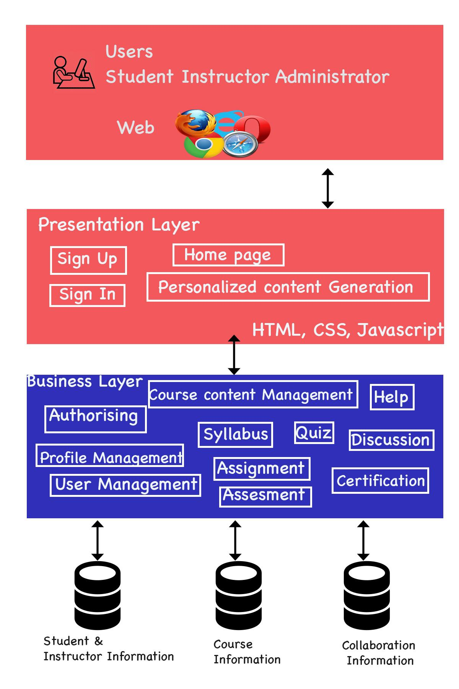

## 4.2 Description:

**4.2.1 Users**

Users of our system include students, instructors and administrators.

**4.2.2 User Interface**

The system should support mainstream browsers including Safari, IE, Chrome, Firefox and Opera.

**4.2.3 Presentation Layer**

For presentation layer, we plan to use HTML, CSS, and JavaScript to implement it.

**4.2.3.1 Sign up**

* This element allow a user to register as a student or an instructor.
* Once a user successfully signs up to our system, the system should generate a profile for him/her.

**4.2.3.2 Sign in**

* This element should allow a user to sign in with a valid signed-up account.
* This feature should identify if a user sign-in as a student or an instructor.
* An administrator should have separate identification to sign in.

**4.2.3.3 Home page**

* This element is the landing page when the system is open through a browser.
* This feature is the landing page once a user successfully signs in.
* This feature should provide link to other accessible modules for each specific user in the system.
* When in other modules, a user should have a link back to this feature.

**4.2.3.4 Personalized content Generation**

* For each user, the system should record the course he/she takes.
* For each user, the system should record the progress of each course he/she takes.
* For each user, the system should display up-coming events.

**4.2.4 Business Layer**

**4.2.4.1 Course content management:**

* This module should allow an administrator to add/remove a course.
* This module should allow an instructor to modify course content, including syllabus, quizzes, assignments, and course content.

**4.2.4.2 Help:**

* This module should show a user manual of the system.
* A user should be able to browse help for operations he/she is authorized to do in the system.
* This module allows user to seek help to the administrator to cope up with system issues.

**4.2.4.3 Authorizing:**

* This module should record a user's identification as a student, an instructor, or an administrator.
* This module should only allow a user to do operations that he/she is authorized to do in the system.

**4.2.4.4 Syllabus:**

* This module provides general information of a course.
* An instructor or an administrator should be able to modify it.
* All users should be able to read the information.

**4.2.4.5 Quiz:**

* An instructor should be able to add/remove/modify a quiz.
* A student should be able to take a quiz after he/she taking the corresponding course.
* A quiz should have corresponding gradebook.

**4.2.4.6 Assignment:**

* An instructor should be able to add/remove/modify an assignment.
* A student should be able to do an assignment after he/she taking the corresponding course.
* An assignment should have corresponding gradebook.

**4.2.4.7 Discussion:**

* This component should enable students and instructors to communicate through the system.
* A discussion should follow a specific course.

**4.2.4.8 Profile Management:**

* A student should be able to modify his/her profile.
* A student should be able to take/drop a course.
* An instructor should be able to modify his/her profile.
* An instructor should be able to apply to instruct a course or cancel to be instructor of a course.

**4.2.4.9 User Management:**

* An administrator should be able to add/remove student from a course.
* An administrator should be able to approve/decline application of a user to be an instructor of a course.

**4.2.4.10 Assessment:**

This module grades the student based on his/her performance in the quiz and assignment.

**4.2.4.11 Certification:**

* After a student finishes a course, the system should provide standard to test if he/she should be certificated for this course.
* This feature should record if a student has passed a course.

**4.2.5 Database:**

It is planned to have three main tables in the database for:

a. Student and instructor information including their personal profiles, related courses, and authorization in the system.

b. Course information including syllabus, course content and quiz/assignment.

c. Collaboration information including the discussion board.